Name___________________________________ Period___________ Binder #__________
University of Utah
Mouse Cloning Lab
Directions:
-Go to the website: http://learn.genetics.utah.edu/content/tech/cloning/clickandclone/
-Follow the “Click and Clone” directions to clone Mimi the mouse
-Answer the questions as you complete the assignment

- Step #1:

1a-Which mouse provides the somatic cell?

1b- Which mouse provides the egg cell?

- Step #2:

- Step #3

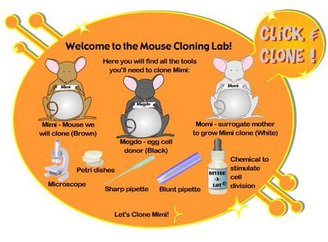
3a: The nucleus from the ______________cell is transferred to the _________________

- Step #4:

4a- What was the purpose of waiting before beginning step #5?

4b- What is the name of the “ball” or 16 cells that is now in the petri dish?

- Step #5:

- Step #6:

- Who is genetically the mother and father of the newly cloned mouse pup?

