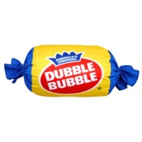
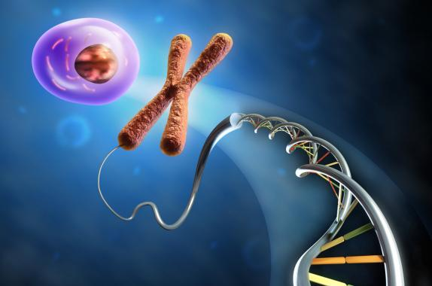
“Cheap and Easy” Biology Labs
Science of Agriculture
- Bubbles Lab – From Ag Bio CD
- Sugar in Bubble Gum - handout
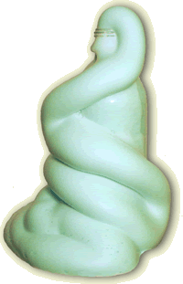
- Other ideas ___________________________________________
Chemistry of Cells
- Reactions – Elephant Toothpaste http://www.sciencebob.com/experiments/toothpaste.php
- Polymers – Diaper – demo; can also be used as soilless media
- Blues the Clue: Souring Milk – ATIC https://utah.agclassroom.org/teachercenter/index.cfm?
controller=main&action=downloadonly&key=584
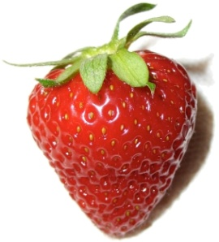
- Other ideas ____________________________________________
Cells
- A tour of the cell http://www.nsf.gov/news/overviews/biology/interactive.jsp
- Other ideas ____________________________________________
DNA/Genetics
- Gleeps – From Ag Bio CD
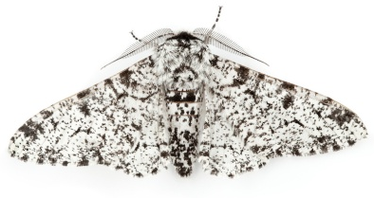
- Strawberry DNA – Demo - https://utah.agclassroom.org/teachercenter/index.cfm?
controller=main&action=downloadonly&key=586
- Other ideas ____________________________________________
Changes through Time
- Competitive Interactions – From Ag Bio CD
- Butterfly activity – From Ag Bio CD
- Other ideas ____________________________________________
Energy
- Flaming Cheetos (or marshmallows, or almonds) - https://utah.agclassroom.org/
teachercenter/index.cfm?controller=main&action=downloadonly&key=595
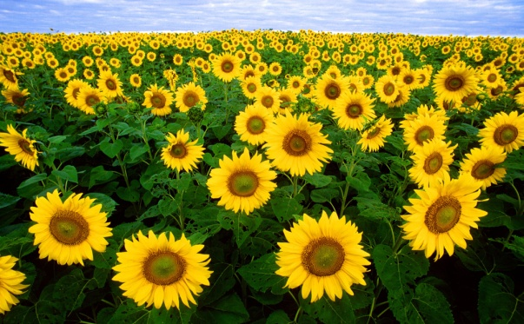
- Other ideas ____________________________________________
Other Ideas:
Biology Labs: http://serendip.brynmawr.edu/sci_edu/waldron/
Steve Spangler Science: http://www.stevespanglerscience.com/
AITC: https://utah.agclassroom.org/
Agroworld Biology: http://agclassroom.org/agroworld/biology.htm

